**DAILY ONLINE ACTIVITIES SUMMARY**

|  |  |  |  |  |  |  |  |  |
| --- | --- | --- | --- | --- | --- | --- | --- | --- |
| **Date:** | **13/06/2020** | | | | | **Name:** | **Katira Krishna J** | |
| **Sem & Sec** | **8th A** | | | | | **USN:** | **4AL16CS045** | |
| **Online Test Summary** | | | | | | | | |
| **Subject** | | **IOT** | | | | | | |
| **Max. Marks** | | **30** | | **Score** | | | **27** | |
| **Certification Course Summary** | | | | | | | | |
| **Course** | **Data Visualization using python** | | | | | | | |
| **Certificate Provider** | | | **Cognitiveclass.ai** | | **Duration** | | | **10 hours** |
| **Coding Challenges** | | | | | | | | |
| **Problem Statement: Python program to check whether a given number is even or odd recursively** | | | | | | | | |
| **Status: Completed** | | | | | | | | |
| **Uploaded the report in Github** | | | | | **Yes** | | | |
| **If yes Repository name** | | | | | **Krishna_Katira** | | | |
| **Uploaded the report in slack** | | | | | **Yes** | | | |

Online Test Details:

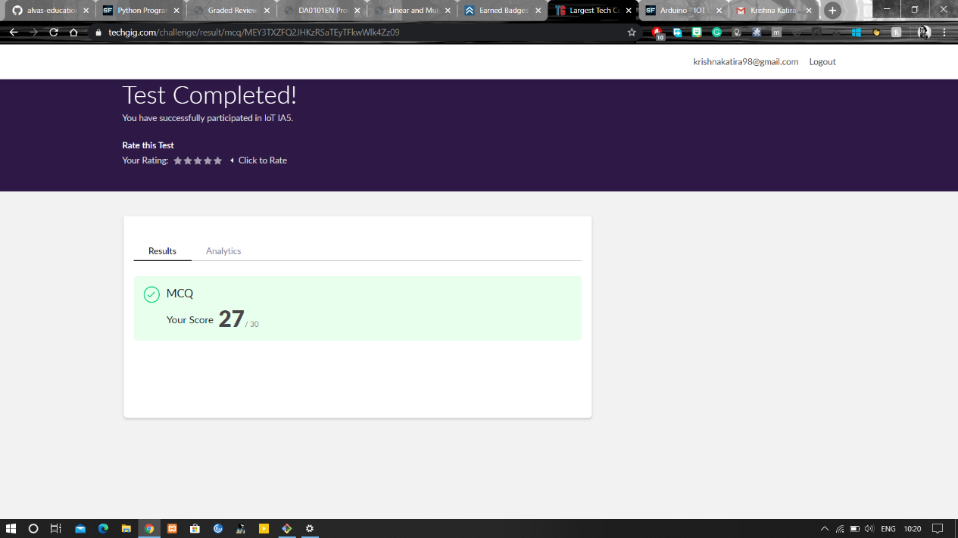

Certification Course Details:

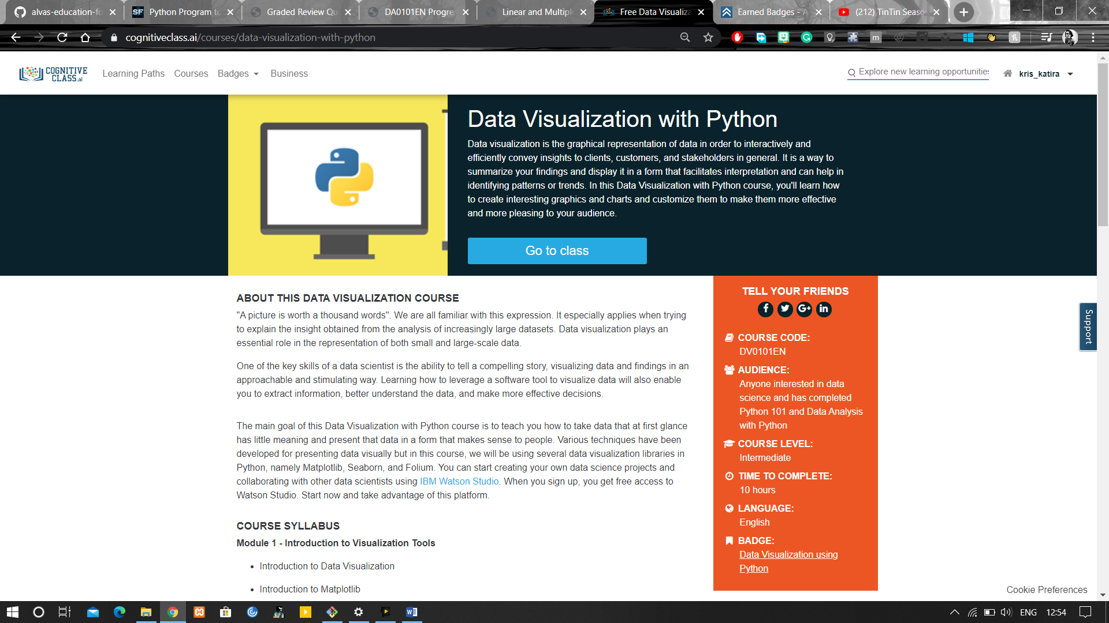

Coding Challenges Details:

**Program:**

def check(n):

if (n < 2):

return (n % 2 == 0)

return (check(n - 2))

n=int(input("Enter number:"))

if(check(n)==True):

print("Number is even!")

else:

print("Number is odd!")